PROJECT OBJECTS\Contract Management

New Fields, Label Changes and Fields Calculation in FWA C.O. Form

|  |  |  |  |
| --- | --- | --- | --- |
| **Revision** | **Date** | **Description** | **Author** |
| 01 | 22/07/2022 | New Fields, Label Changes and Fields Calculation in FWA C.O. Form | G. Riccardi |

© 2015 Project Objects Srl

Via Pellettier, 4 – 20900 Monza (MB) - Italy

Tel. +39 039 - FAX +353-46-9282099

Table of Contents

1. Add new Type of Changes in FWA C.O. Form 3

2. Renaming Fields in FWA C.O. Form 3

3. Converted in (€) Fields to be Added to FWA C.O. Form 3

4. Change LABEL in FWA C.O. Form and PDF Form 4

5. Add new Field in FWA C.O. Form 4

6. Fields Calculation in FWA C.O. Form 5

7. FWA C.O. PDF Update 6

# Add new Type of Changes in FWA C.O. Form

* **Implementation logic and implementation requisite**

New Type of change to be added: **05 - Changes to the payment milestone**

**THIS POINT (point 1) CAN BE DONE BY GUIDO/DANILO as we did so do not need to be estimated**

**But please the modification should reflect PDF As Well**

# Renaming Fields in FWA C.O. Form

* **Implementation logic and implementation requisite**

**Field:**

Possible Tolerance

To be renamed in:

Possible Contractual Tolerance

**THIS POINT (point 2) CAN BE DONE BY GUIDO/DANILO as we did so do not need to be estimated**

# Converted in (€) Fields to be Added to FWA C.O. Form

* **Implementation logic and implementation requisite**

Field to be added to FWA C.O. Form and Retrieved from FWA Form :

Possible Contractual Tolerance

The new Field converted will be called:

Possible Contractual Tolerance (€)

Activated Tolerance

The new Field converted will be called:

Activated Tolerance (€)

Possible Contract Options Existing in the Contract

The new Field converted will be called:

Possible Contract Options Existing in the Contract (€)

Activated Contract Options

The new Field converted will be called:

Activated Contract Options (€)

Total Amount of C.O. already approved  
The new Field converted will be called:

Total Amount of C.O. already approved (€)

Those Fields must come from FWA Form

# Change LABEL in FWA C.O. Form and PDF Form

* **Implementation logic and implementation requisite**

Change Label in **FWA C.O. Form and PDF Form**

Renaming Fields in Form and PDF.

1. %CO increase vs Overall Amount: to be renamed in “Percentage Increase of this Contract Amendment regarding Contract amount”.
2. %CO increase vs Base Amount: to be renamed in “Percentage Increase of this C.O. and all previous C.O. regarding Contract amount”.
3. Capex Coverage section to be renamed changing this “1st Approved Capex” con “last Approved Capex”.

4 Change label in FWA/PRJ C.O. form and PDF form:

The term “MPC” should be changed to “Major Project Cmte”

**THIS POINT (point 4) CAN BE DONE BY GUIDO/DANILO as we did so do not need to be estimated**

**But please the modification should reflect PDF As Well**

# Add new Field in FWA C.O. Form

* **Implementation logic and implementation requisite**

Add those new fields:

* **C.O. Included in Allocated Contract Contingency** (Dropdown YES/NO, like in PRJ C.O. Form) to be placed after the Field: **Request Shared with Procurement**
* **Budget Coverage** (Dropdown YES/NO) to be placed after the Field: **Type of Changes**
* **Major Project Cmte Approval Needed** to be placed after the Field: **C.O. Included in Allocated Contract Contingency** (Logic in point 6.3 below)

# Fields Calculation in FWA C.O. Form

* **Implementation logic and implementation requisite**

Change Fields Calculation in **FWA C.O. Form**

1. The Field: **Issued C.O. Amount** new logic:  
   it should be filled from "Total Change Order Amount" at the moment of Finalization, then it need to be also editable from FWA Manager (from FWA Form) after the WF is FINALIZED
2. The Field: **Percentage Increase of this C.O. and all previous C.O. regarding Contract amount** new logic: change the formula in (CO+COs)/(B+T+O)

In detail:

[Sum of “Change Orders Amount” (From Framework Agreement Form for the FWA related to this C.O.) + (Total Change Order Amount (from this Form)] / [“FA Base Amount” + “Possible Contractual Tolerance” + “Possible Contract Options Existing in the Contract”]

1. The Field: **Percentage Increase of this Contract Amendment regarding Contract amount** new logic:

detail:

[ (Total Change Order Amount (from this Form)] / [“FA Base Amount” + “Possible Contractual Tolerance” + “Possible Contract Options Existing in the Contract”]

1. Field: **Major Project Cmte Approval Needed** set to **YES** if:

[ (“FA Base Amount (€)” + “Possible Contractual Tolerance (€)” + “Possible Contract Options Existing in the Contract (€)”) + “Total Change Order Amount (€) " (this C.O.Form) + “Total Amount of C.O. already approved (€)" > 25M€]

AND

("C.O. Included in Allocated Contract Contingency" = **N**)

AND

("Total Amount of C.O. already approved (€)” + "Total Change Order Amount (€)” (from this Form)) > 5% of ("FA Base Amount (€)+ Possible Contract Options Existing in the Contract (€) + Possible Contractual Tolerance (€)”)

OR

[ (“FA Base Amount (€)” + “Possible Contractual Tolerance (€)” + “Possible Contract Options Existing in the Contract (€)”) + “Total Change Order Amount (€) " (this C.O.Form) + “Total Amount of C.O. already approved (€)" > 25M€]

AND

("C.O. Included in Allocated Contract Contingency" = **N**)

AND

("Total Amount of C.O. already approved (€)” + "Total Change Order Amount (€)” (from this Form)) > 25M)

Field: **Major Project Cmte Approval Needed** set to **NO** in any other cases

# FWA C.O. PDF Update

* **Implementation logic and implementation requisite**

**Update the PDF with all the new Label specified in specs above**, plus add the following New Fields as Follow:

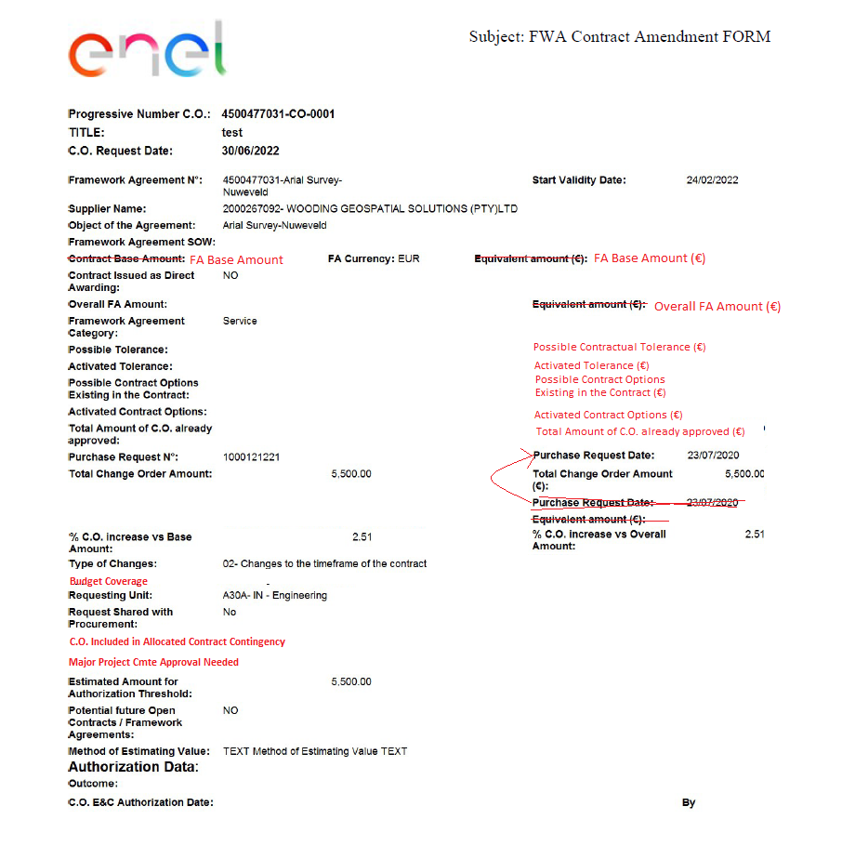

**Keep the other Page AS IS (with Change Order Analysis details)**